**Position overlap functionality**

**To be used when replacing a leaver and there is to be a handover period** (involving double occupancy of a position) **of one month or less.** Any longer than this then a new position should be created instead.

Images in this document are for illustrative purposes, displaying screenshots with icon positions and highlighted fields.

1. From the **My Oracle Home Page**, in the *horizontal menu bar in the centre of the* **Home Page**, select **My Team**, then select **My Team** from the Apps area

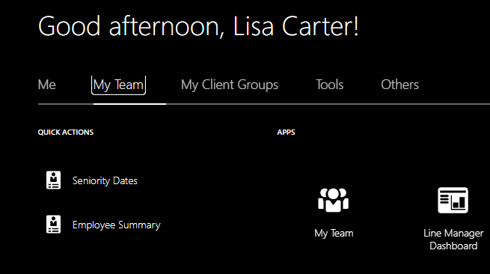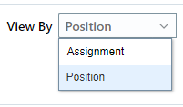

1. Use the **View By** menu *in the centre of the screen* to select **Position**
2. Positions in your team are listed in rows. Available Positions in your team will show **0 FTE** and will *not have* a named individual on that row

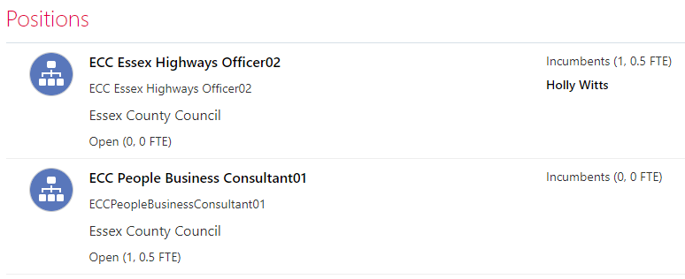

Filled Positions will have a number in the FTE field and the name of the person in that filled Position

1. Find the row relating to the Position you want to edit

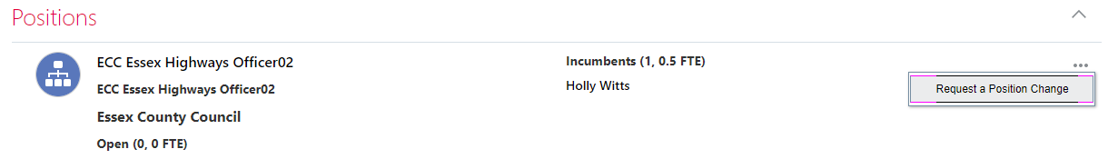

1. Using the **More Options menu** (three dots …) *to the far right* of the relevant Position, select **Request a Position Change**
2. In the **When and Why** section, complete the **When does the position change start?** field using the calendar icon

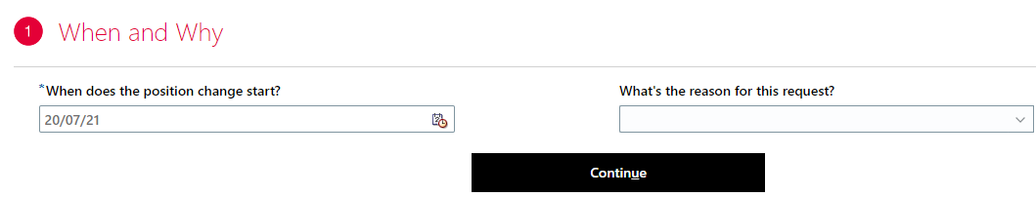

1. Complete the **What’s the reason for this request?** field using the drop down menu. Select “Job Change” if the reason is to just swicth the overlap functionality on
2. Select **Continue**
3. Scroll down and select “Yes” under the **Overlap Allowed** field 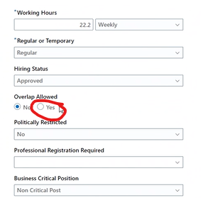



1. At the bottom of the section, select **Continue**

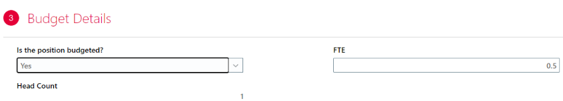

1. In the **Budget Details** section, update the **Is the position budgeted?** field, using the drop down menu, and **FTE** field, by overtyping if necessary



1. *At the bottom of the section*, select **Continue**

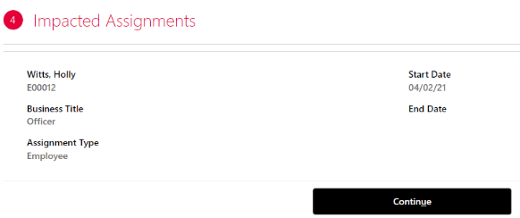

1. A section called **Impacted Assignments** appears, confirming the person who is affected by your change/s. *At the bottom of the section*, select **Continue**

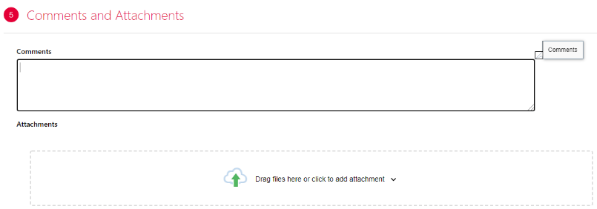

1. In the **Comments and Attachments** section, add relevant comments and files to support the change. Here you should detail how long the overlap will be switched on for
2. At the *top right of the screen*, select **Submit** to send the change for approval, or **Cancel** to remove the request.